



**Table of Contents**

**Section 1 – The Dashboard** 3

**Section 2 – The Dataset** 6

**Tableau** 6

**Data Preparation & Preprocessing** 6

**Section 3 – Dashboard Users** 8

**List of the Final Set of Questions** 10

**Section 5 - Plots** 11

**List of Plots** 11

**Section 6 - Dashboard Interactivity** 23

**Extra Credit** 24

**References** 27

**Mural Board** 27

**Data Set** 27

**Published Tableau** 27

# **Section 1 – The Dashboard**

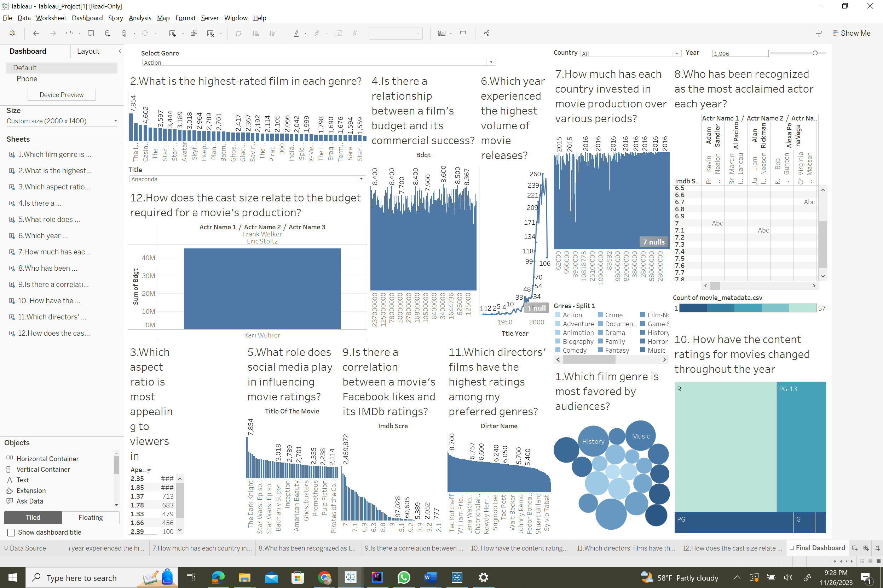

The dashboard seen above is a comprehensive analytical tool that visualizes data from the film business, answering essential questions about film performance, popularity, and trends. It features a variety of visualizations, including a bubble chart that maps the popularity of cinema genres, bar charts that highlight top-rated films within each genre and track investment in film production by different countries, and a timeline that shows the volume of movie releases over time. Other sections discuss the impact of social media on movie ratings, the relationship between a film's budget and financial success, and the shifting landscape of content ratings. These visual components, when combined, synthesize complex data into a story about the film industry's past and present, providing a valuable resource for understanding how numerous aspects contribute to a film's success and reception.

Couple of other Dashboard views by filtering

1. When Genre is selected as Horror

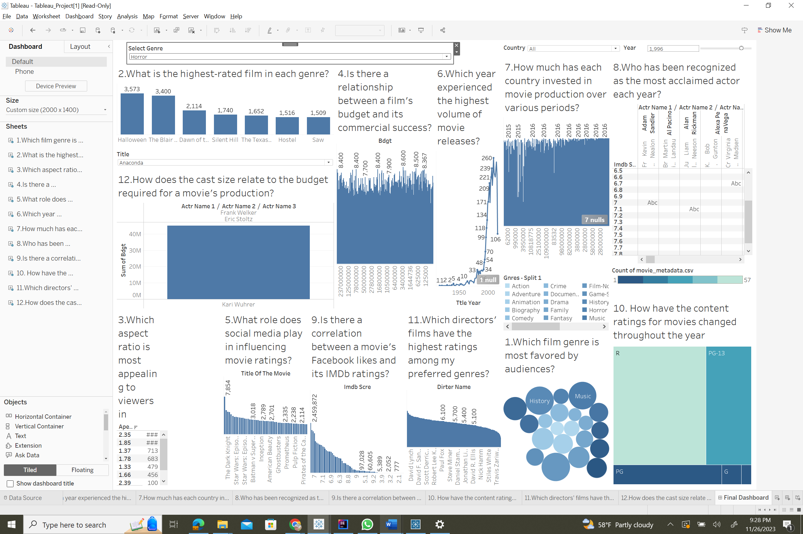

1. When Genre is selected as Romance

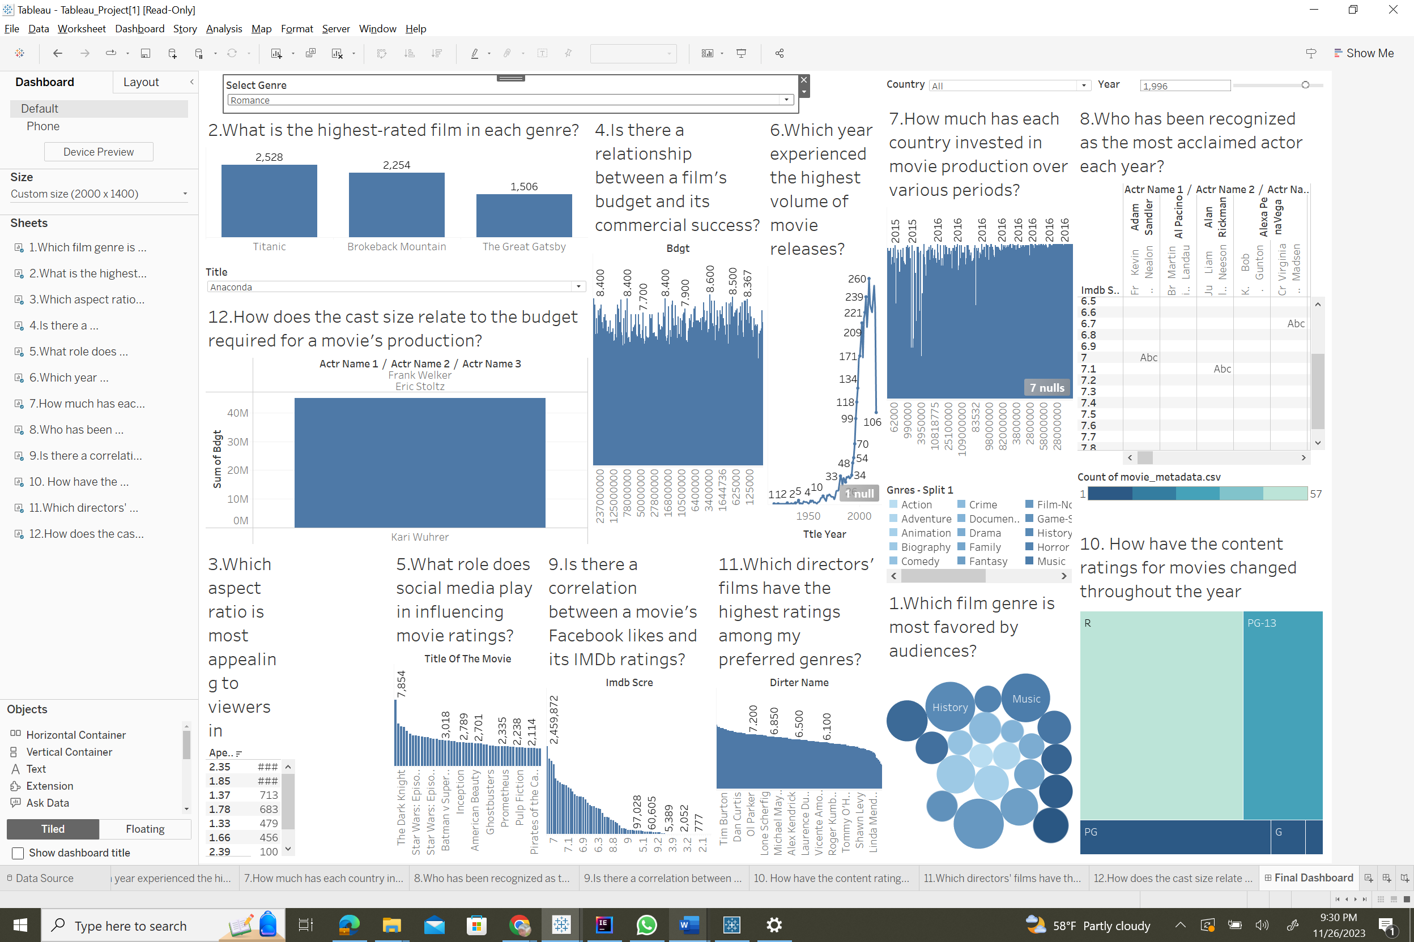

1. When country is selected as Russia

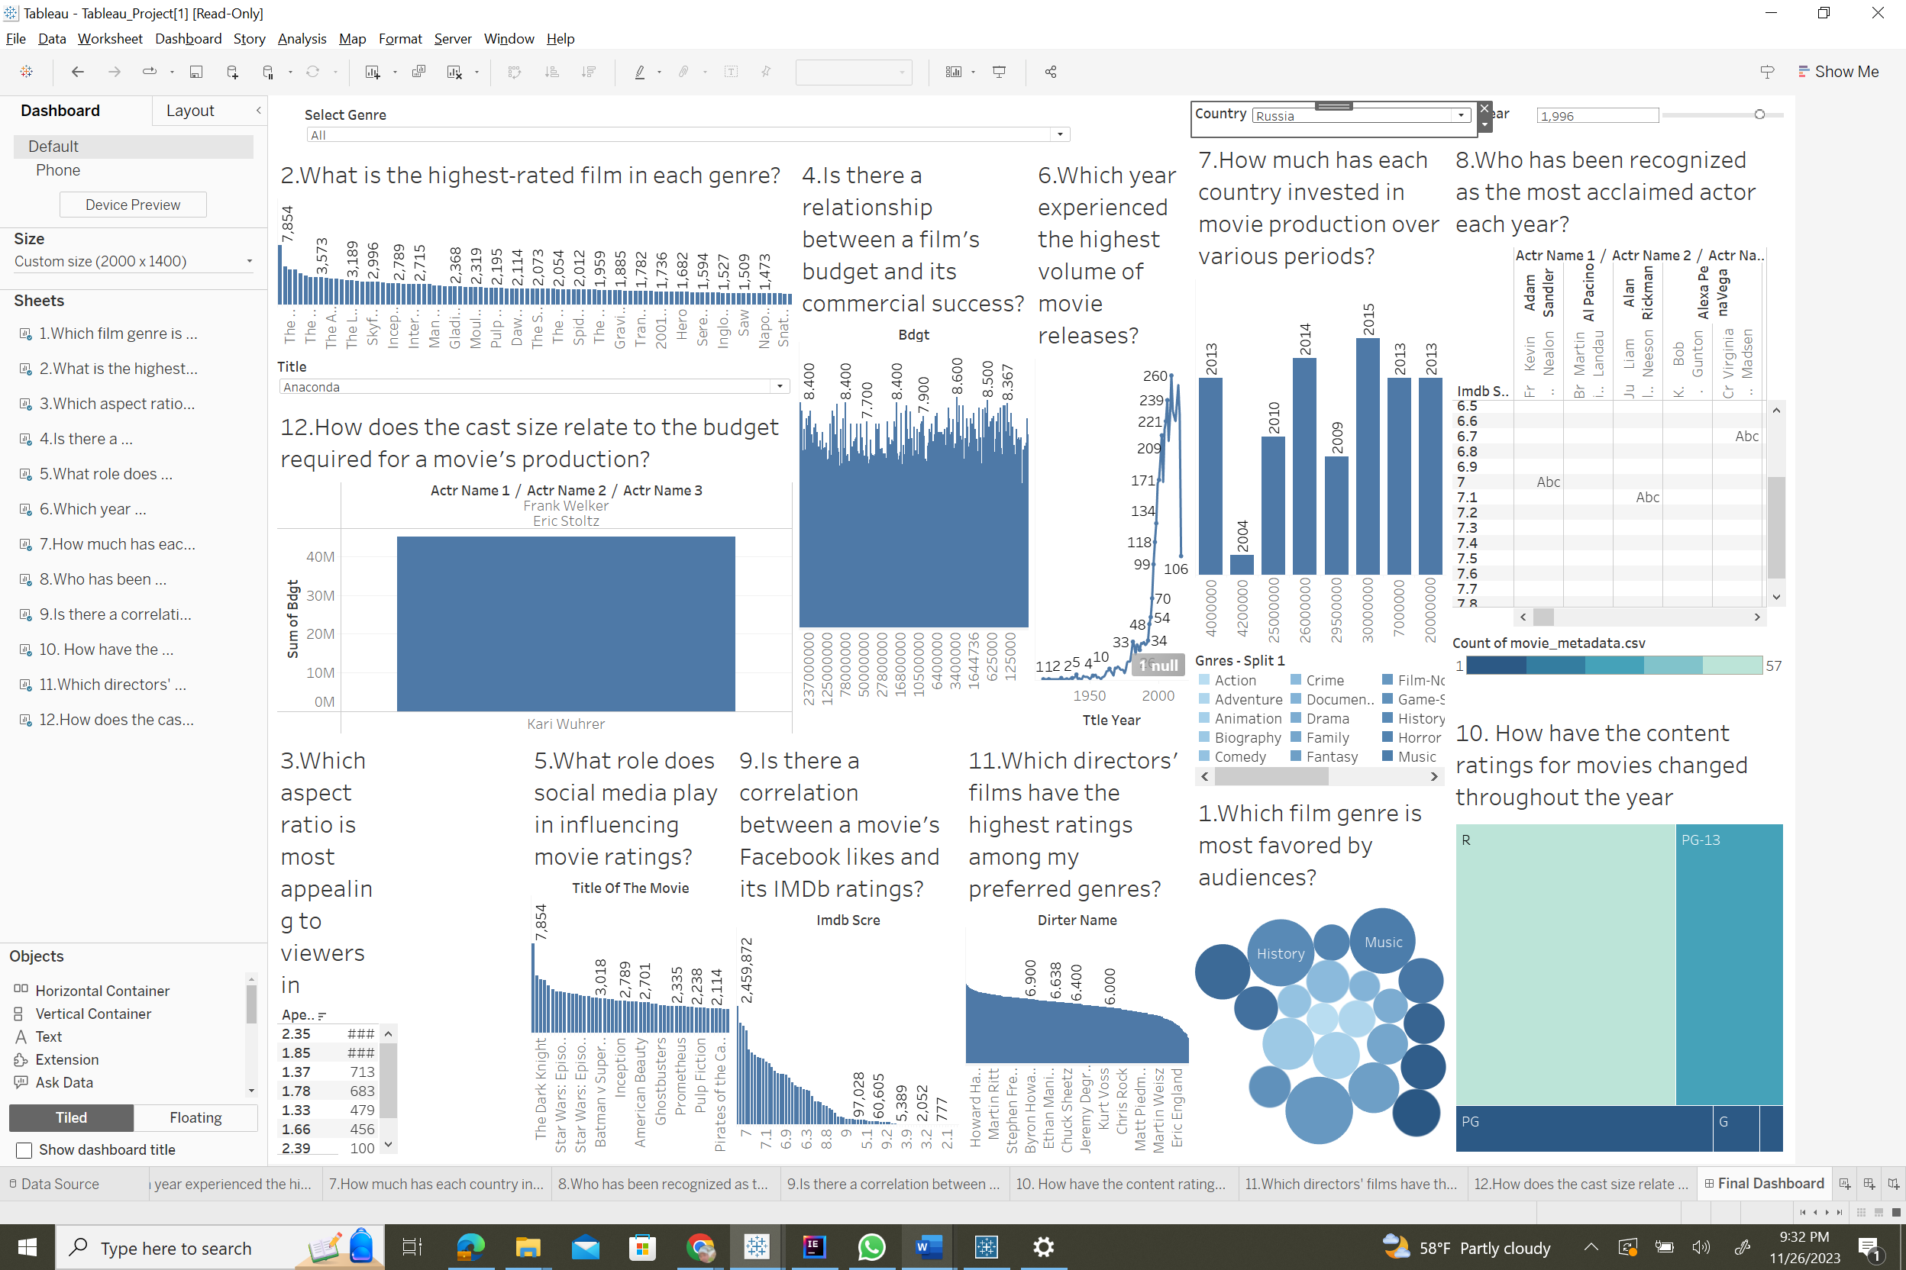

1. When year is selected as 1961

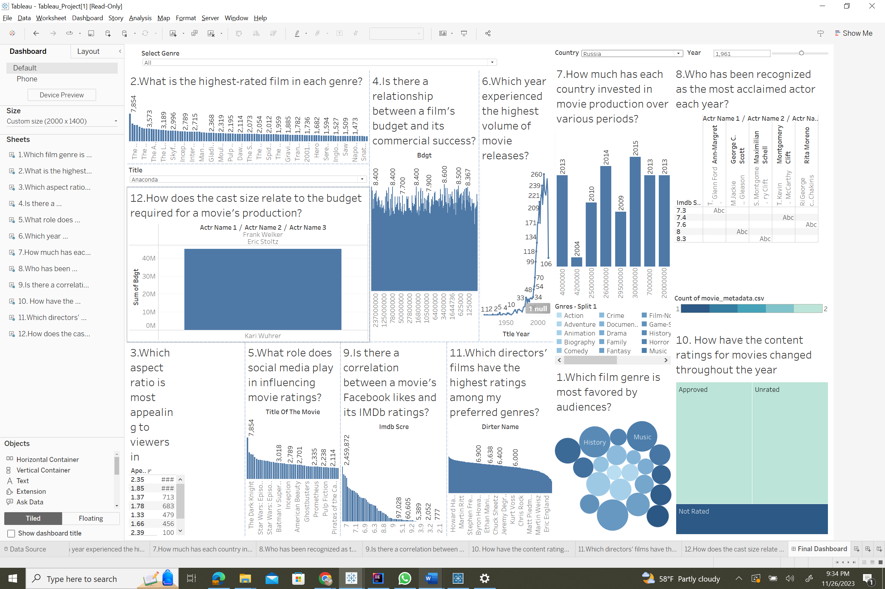

# **Section 2 – The Dataset**

## **Tableau**

In opting for Tableau as the preferred visualization tool, the decision is grounded in its user-friendly interface, expansive data connectivity, and robust visualization capabilities. The intuitive drag-and-drop functionality simplifies the visualization process, accommodating users with diverse technical proficiencies. With compatibility across a wide spectrum of data sources, Tableau ensures flexibility, enabling seamless integration for diverse datasets. The platform's extensive visualization options, coupled with interactive features and drill-down capabilities, empower the creation of dynamic dashboards offering comprehensive insights. Leveraging a supportive user community and rich online resources, Tableau fosters an environment conducive to efficient learning. Its scalability, integration flexibility, and commitment to continuous improvement position Tableau as a reliable choice—from small-scale projects to enterprise solutions—providing a sturdy foundation for diverse data visualization needs.

## **Data Preparation & Preprocessing**

The dataset comprises two main files: main_data.csv: movie_metadata.csv:

In the realm of our movie dataset encapsulating details of 45,000 films globally, a pivotal preprocessing phase was meticulously executed to enhance the dataset's suitability for creating interactive dashboards and visualizations. Commencing with an initial dataset of 5044 rows and 28 columns, a discerning examination revealed certain columns to be redundant or extraneous for our specific visualization objectives. Opting for SQL as a proficient preprocessing tool, we judiciously employed it to selectively excise columns that did not contribute substantive insights to our visual representation goals. The curation process involved the targeted removal of specific properties and records, focusing on refining the dataset. Noteworthy exclusions encompassed columns such as actor_facebook_likes, director_facebook_likes, movie_facebook_likes, movie_imdb_link, facenumber_in_poster, and Num Critic for Reviews. This intricate preprocessing ensures that the dataset now centers on pivotal attributes, paving the way for a more streamlined and purposeful representation in Tableau, aligning seamlessly with our envisioned visualizations and analytical pursuits.

|  |  |  |  |
| --- | --- | --- | --- |
| **#** | **Attribute** | **Description** | **Data Type** |
| 1 | actr_name_1 | Actor Names | Nominal |
| 2 | actr_name_2 | Actor Names | Nominal |
| 3 | actr_name_3 | Actor Names | Nominal |
| 4 | gnres | Genre(s) associated with the movie | Nominal |
| 5 | title_of_the_movie | Title of the movie. | Nominal |
| 6 | dirter_name | Name of the director of the movie. | Nominal |
| 7 | clr | Indicates whether the movie is in color. | Nominal |
| 8  9 | Dration  gss | Duration (length) of the movie.  Genre code or identifier. | Ratio  Ratio |
| 10 | lang | Language in which the movie is produced. | Nominal |
| 11 | cntry | Country where the movie was produced. | Nominal |
| 12 | Bdgt | Budget allocated for the production of the movie. | Ratio |
| 13 | ttle_year | Year when the movie was titled or released. | Interval |
| 14 | imdb_scre | IMDb rating of the movie. | Ratio |
| 15 | apec_ratio | Aspect ratio of the movie. | Ratio |
| 16 | fb_likes | Total Facebook likes associated with the movie. | Ratio |

The following will be the final dataset attributes following preprocessing:

# **Section 3 – Dashboard Users**

1. **Film Producer:**

Film producers can use this dashboard to analyze the performance of actors and directors in their previous projects. This information can be valuable when considering casting decisions or selecting directors for upcoming films. They can also use the dashboard to track trends in movie ratings and audience preferences to make informed decisions about the types of films to produce.

1. **Movie Critic/Blogger:**

Movie critics and bloggers can utilize the dashboard to compare their reviews and ratings with those of other critics. This helps them gauge their own performance and identify areas for improvement in their critiques. They can also track the performance of actors, directors, and genres over time, allowing them to provide more insightful commentary on industry trends.

1. **Distribution Strategist:**

Distribution strategists can use this dashboard to assess the potential success of movies in different regions or markets based on historical ratings and audience preferences. They can also analyze the performance of movies on various OTT platforms and make informed decisions about distribution deals and release strategies.

1. **Film Industry Analyst:**

Film industry analysts can leverage the dashboard to gather data on trends in movie ratings, genre popularity, and actor/director performance. This data can be used to provide industry reports, market insights, and recommendations to stakeholders in the film industry.

1. **Data Scientist:**

Data scientists can work with the data behind the dashboard to perform in-depth analyses, such as predictive modeling for box office success or identifying hidden patterns in movie ratings. They can also help improve the dashboard's algorithms and data processing to provide more accurate and valuable insights.

1. **Streaming Service Curator:**

Streaming service curators can use the dashboard to identify top-rated movies and trending genres. This helps them make content curation decisions for their platforms. They can also assess the performance of movies on their platform compared to competitors and use this data for content acquisition and promotion.

1. **Movie Enthusiast:**

Movie enthusiasts can explore the dashboard to discover top-rated movies, trending actors, and popular genres. This information can guide their movie-watching choices. They can also use the dashboard to stay informed about industry trends and gain insights into the world of cinema.

1. **Marketing Team Member:**

Marketing team members can use the dashboard to identify movies with high ratings and potential audience appeal. This can inform marketing campaigns and promotional strategies.

They can also analyze the performance of marketing efforts by comparing them to movie ratings and audience feedback.

**Section 4 - Questions**

## **List of the Final Set of Questions**

1. Which film genre is most favored by audiences?
2. What is the highest-rated film in each genre?
3. Which aspect ratio is most appealing to viewers in movies?
4. Is there a relationship between a film's budget and its commercial success?
5. What role does social media play in influencing movie ratings?
6. Which year experienced the highest volume of movie releases?
7. How much has each country invested in movie production over various periods?
8. Who has been recognized as the most acclaimed actor each year?
9. Is there a correlation between a movie's Facebook likes and its IMDb ratings?
10. How have the content ratings for movies changed throughout the year
11. Which directors' films have the highest ratings among my preferred genres?
12. How does the cast size relate to the budget required for a movie's production?

# **Section 5 - Plots**

## **List of Plots**

1. Which film genre is most favored by audiences?

The most popular movie in the genre is depicted in the image below. The data is displayed using a circle scatter plots. Size and color are the pre-attentive attributes that are employed in this.

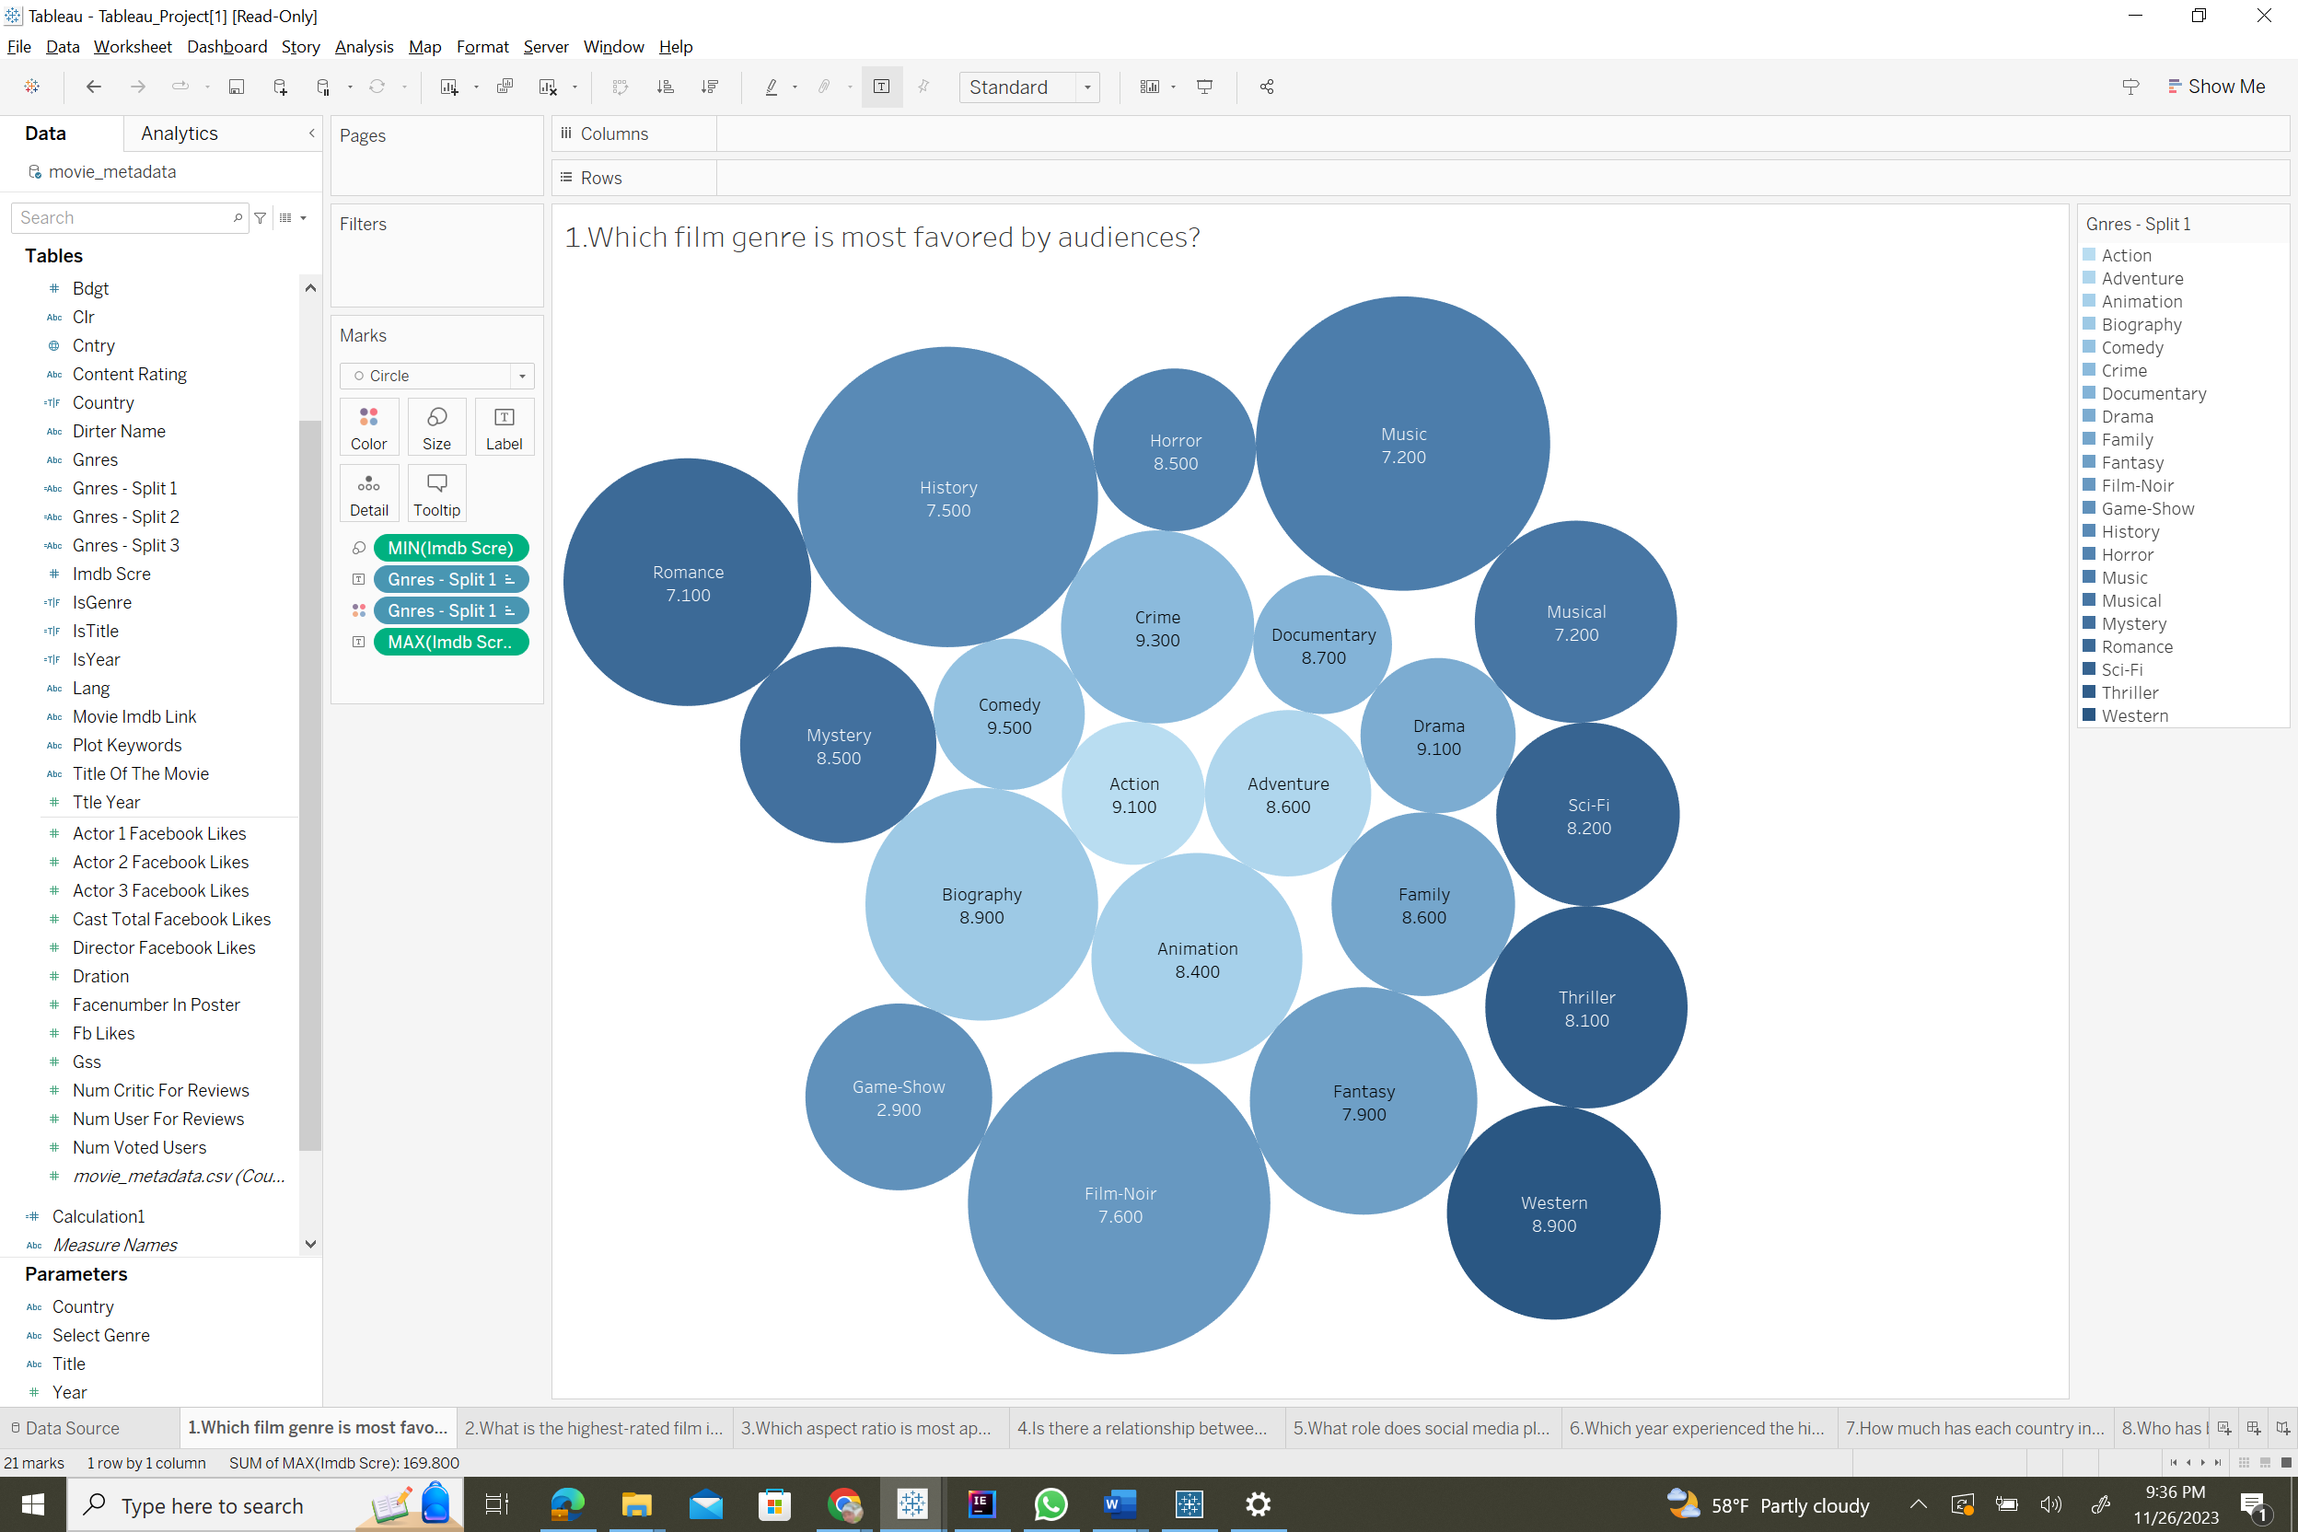

1. What is the highest-rated film in each genre?

The exhibited bar chart is an insightful picture of the top-rated films across many genres. It is intended to answer by demonstrating the diversity of films that have struck a chord with both audiences and critics. Each bar corresponds to a movie title, and they are grouped in descending order of their review scores, allowing for an instant visual comparison of the most praised films in their various genres. This visual tool is especially beneficial for film aficionados who want to explore the greatest of cinema across multiple categories, as well as industry experts who want to analyze patterns in movie ratings.

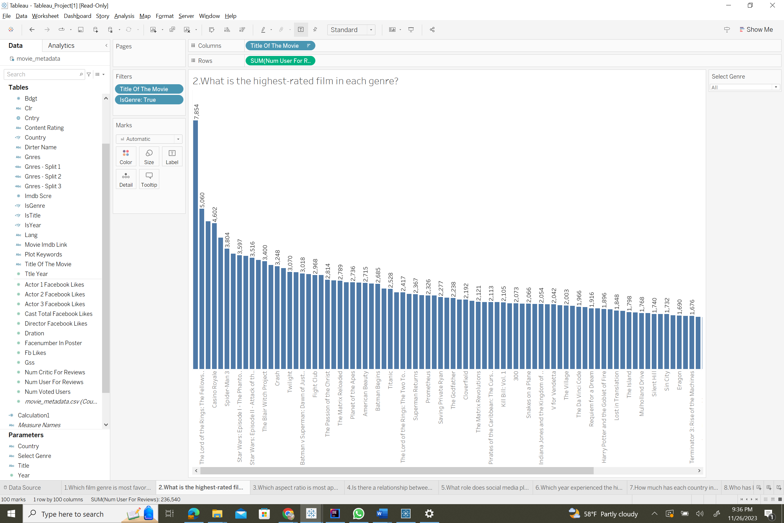

1. Which aspect ratio is most appealing to viewers in movies?

The visualization presents a tabular depiction of movie aspect ratios plotted against the frequency with which they are used. The Y-axis lists the aspect ratios, illustrating the wide range of cinematic formats, while the X-axis quantifies the frequency, providing a clear indicator of each ratio's industry prevalence. The table makes use of the pre-attentive attribute of numerical value, allowing for an instant comparison across the spectrum of aspect ratios to determine which configurations are most appealing in film production.

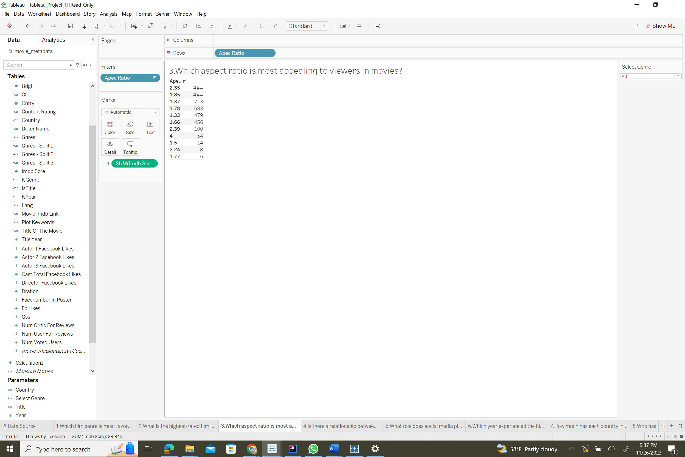

1. Is there a relationship between a film's budget and its commercial success?

This visualization depicts a bar chart that compares a film's budget on the X-axis to its IMDb score on the Y-axis to investigate the relationship between a film's budget and its financial success. Each bar's height corresponds to its IMDb score, functioning as a pre-attentive attribute that allows for a quick assessment of a film's critical reception in relation to its budget. This graphic is useful in determining whether higher film production investments correlate with higher ratings, potentially affecting budget allocation decisions in the film industry.

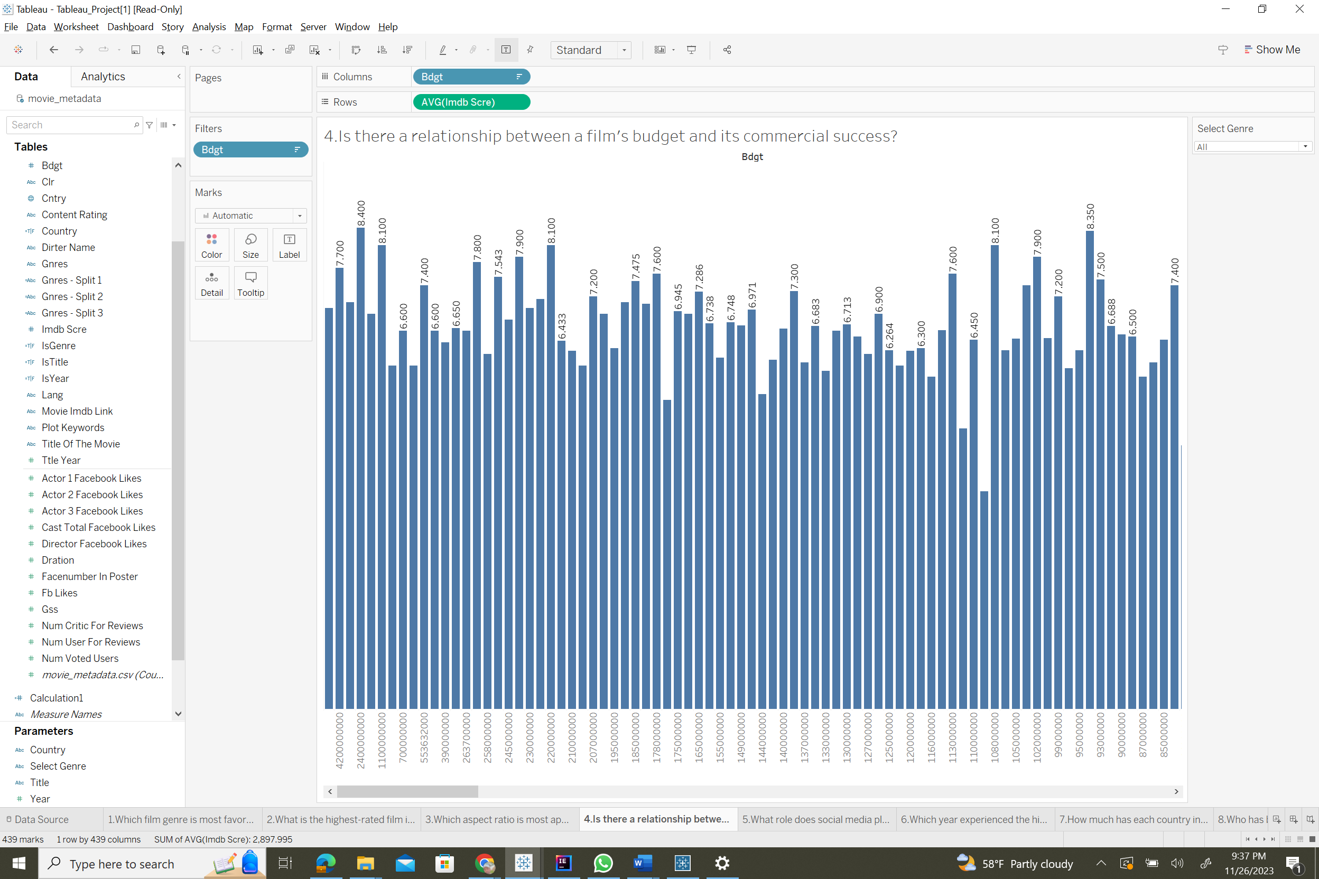

1. What role does social media play in influencing movie ratings?

The visualization depicts a bar chart that investigates the impact of social media on movie ratings. The Y-axis shows the amount of user reviews, which can be used as a proxy for social media engagement, while the X-axis shows specific movie titles. The length of the bars represents the volume of user engagement for each film, offering a visual indicator of the role of social media in the film's reception. This graphic is particularly useful for examining the impact of online buzz and audience interactions on film's perceived popularity and success.

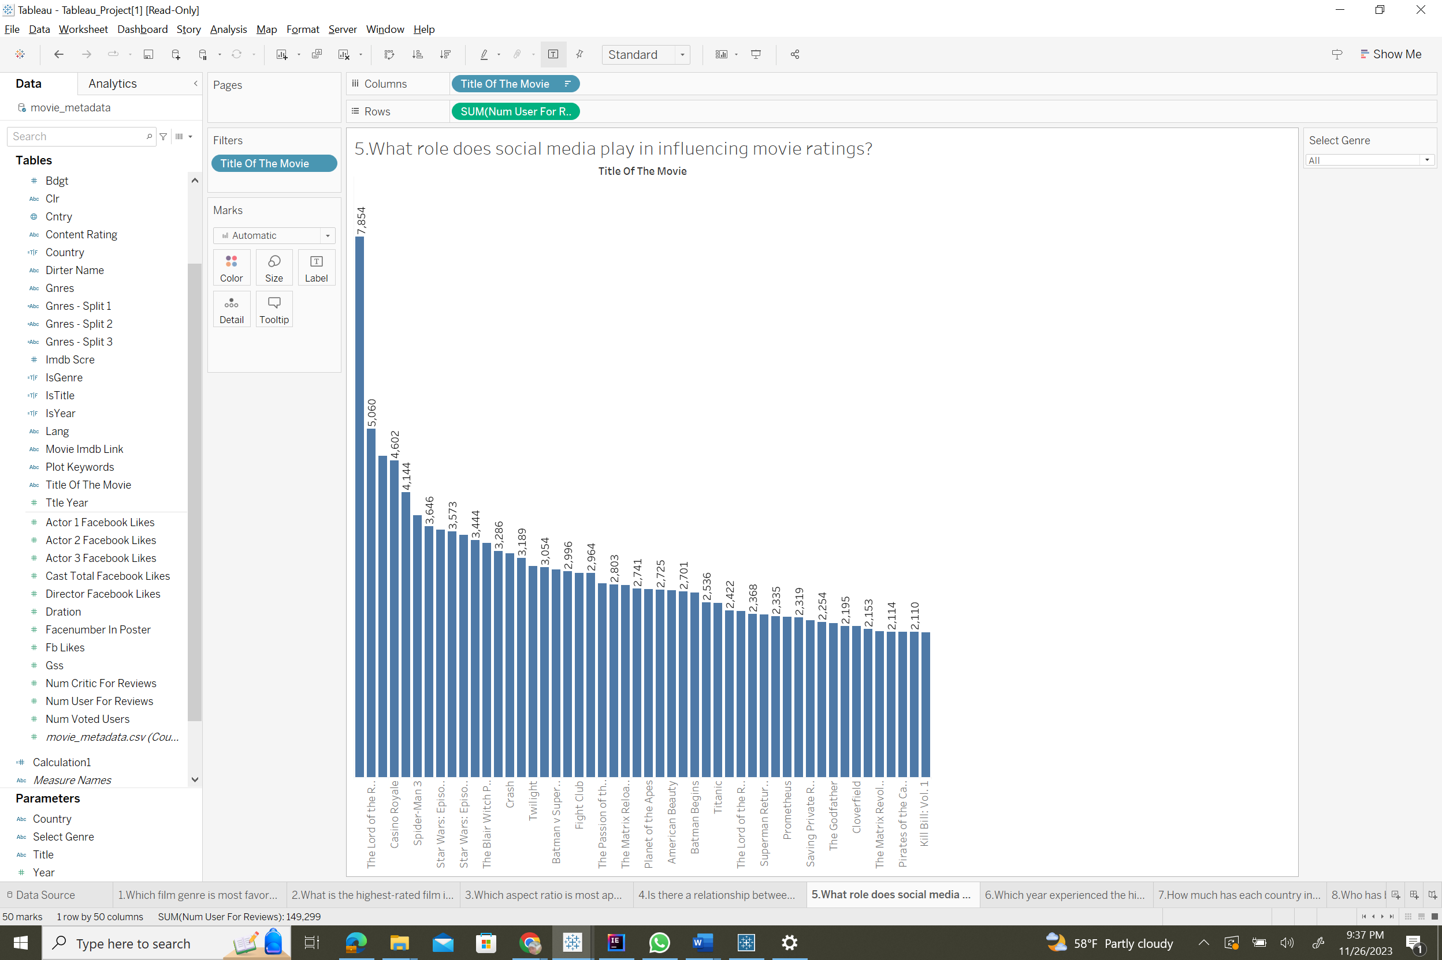

1. Which year experienced the highest volume of movie releases?

This visualization is a line chart that shows the amount of film releases over time. The X-axis depicts history in years, while the Y-axis quantifies the number of movies released each year. The line's peaks and troughs represent fluctuations in movie production, with specific years highlighted for their remarkable high or low release volumes. This visualization efficiently conveys trends and patterns in the film industry's output over time by utilizing the pre-attentive properties of location along the vertical axis and the trajectory of the line.

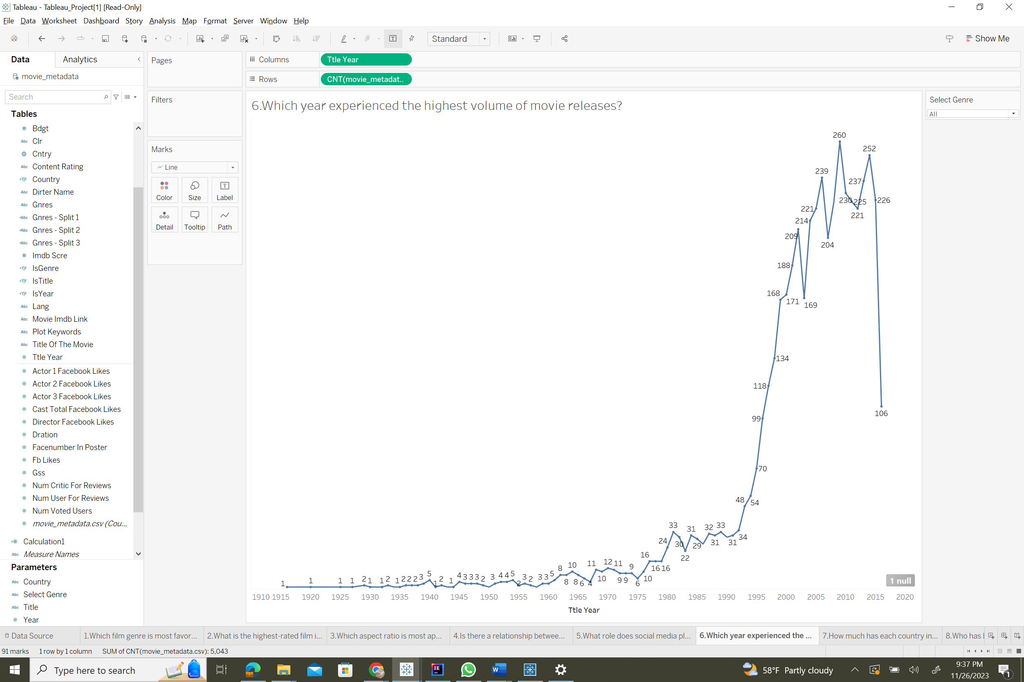

1. How much has each country invested in movie production over various periods?

The illustration depicts a bar chart that compares movie production investments by different countries across different time periods. The Y-axis represents the amount of investment, while the X-axis represents a historical chronology split by year. Each bar represents a year, and the height corresponds to the level of investment in film production for that year. The visualization employs the attention-grabbing properties of length and location to effectively portray countries' financial commitment to the film industry across time, providing insights into the economic dynamics of film production.

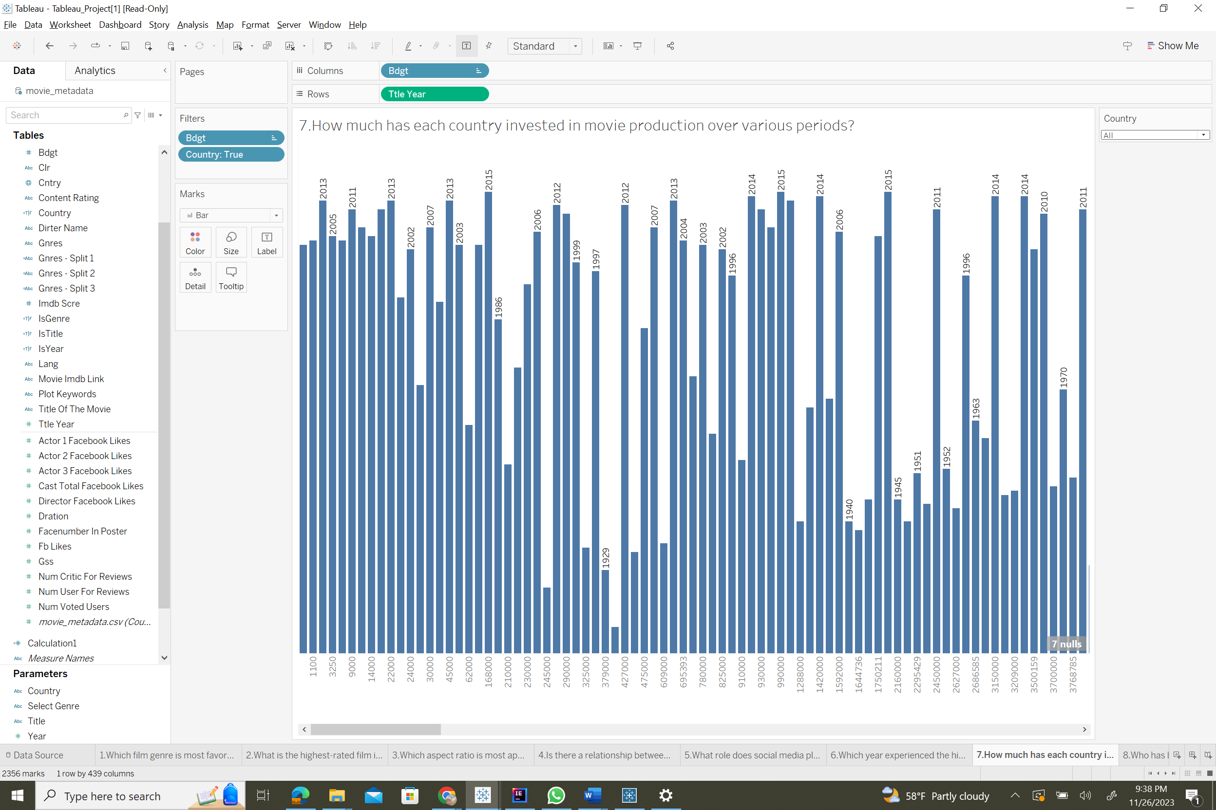

1. Who has been recognized as the most acclaimed actor each year?

This illustrates a data visualization aimed at identifying the year's most acclaimed performers based on IMDb scores. The Y-axis depicts the IMDb score, which is a measure of critical acclaim, and the X-axis lists the names of the actors. The graphic is set up to show numerous actors from different years, most likely using a year filter. The data points for each actor are placed on the graph based on their IMDb score, allowing for rapid comparison of the actors' positions for the chosen year. This setup can be beneficial for tracking performers' performance over time and spotting trends in critical acclaim in the film industry.

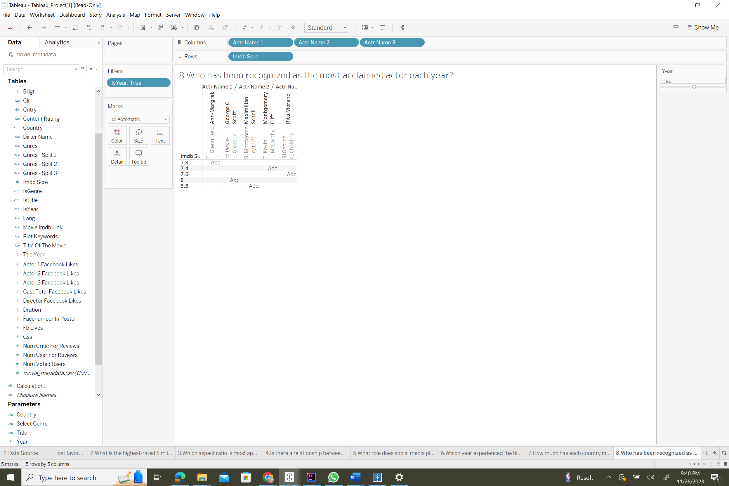

1. Is there a correlation between a movie's Facebook likes and its IMDb ratings?

The image includes a bar chart that investigates the possible relationship between a movie's Facebook likes and its IMDb ratings. The Y-axis is labeled with IMDb scores, which serve as a measure of a film's critical response, while the X-axis includes numerous films. The height of each bar is the IMDb score that correlates to the sum of Facebook likes, as seen in the tooltip. This visualization allows users to determine whether a higher number of social media likes correlates with higher IMDb ratings, potentially demonstrating the impact of social media presence on a film's success and popularity.

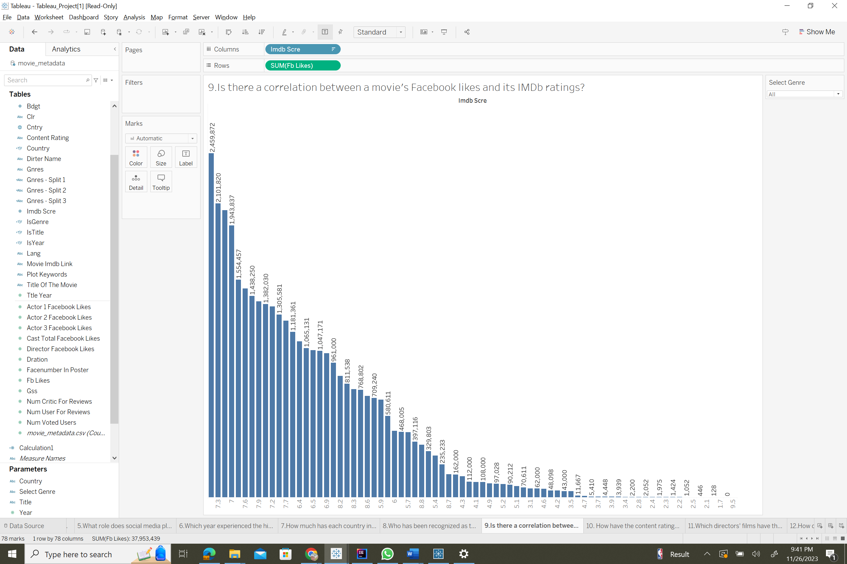

1. How have the content ratings for movies changed throughout the year

The image shows a treemap representation that divides movies into categories depending on their content ratings. Large blocks signify content rating categories like PG-13, PG, R, and Not Rated, with the size of each block equating to the number of movies in that category. This format employs size as a pre-attentive attribute, allowing viewers to rapidly judge the relative quantity of movies in each rating category, providing insight into the distribution of movie content ratings throughout the course of the year.

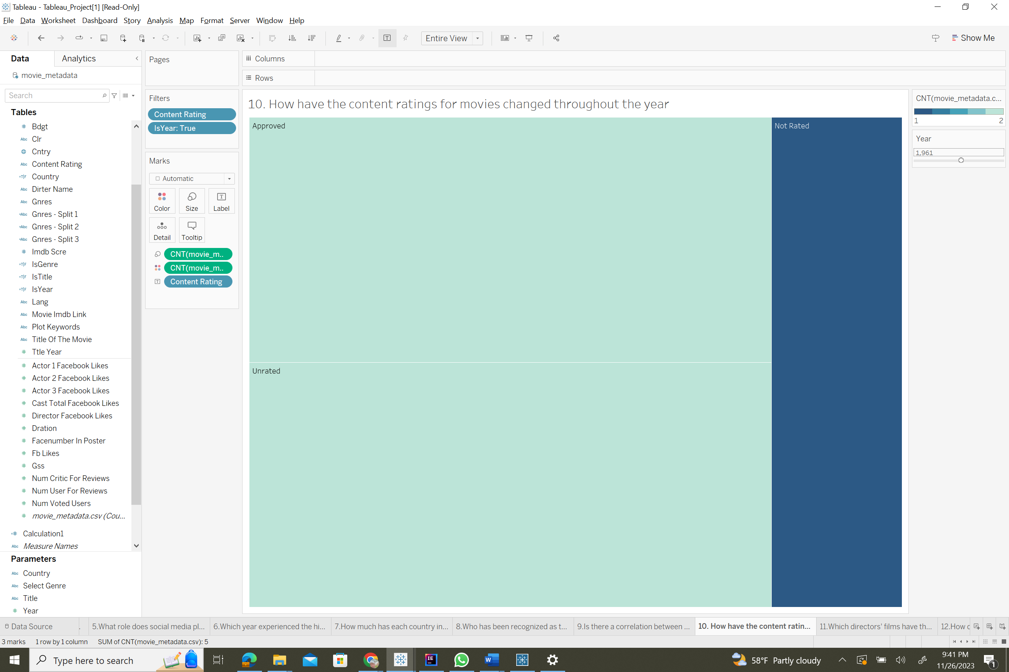

1. Which directors' films have the highest ratings among my preferred genres?

The image illustrates a detailed bar chart that ranks the IMDb scores of films directed by various directors. The X-axis categorizes each director by name, while the Y-axis quantifies each film's average IMDb score, providing a visual depiction of directorial success within the viewer's favored categories. The length of the bars acts as a pre-attentive feature for swiftly comparing the directors' ratings, allowing for an examination of which filmmakers' films resonate more with viewers and critics. This form of visualization can be useful for both fans looking for quality films in specific genres and industry professionals researching the impact of directorial influence on film reception.

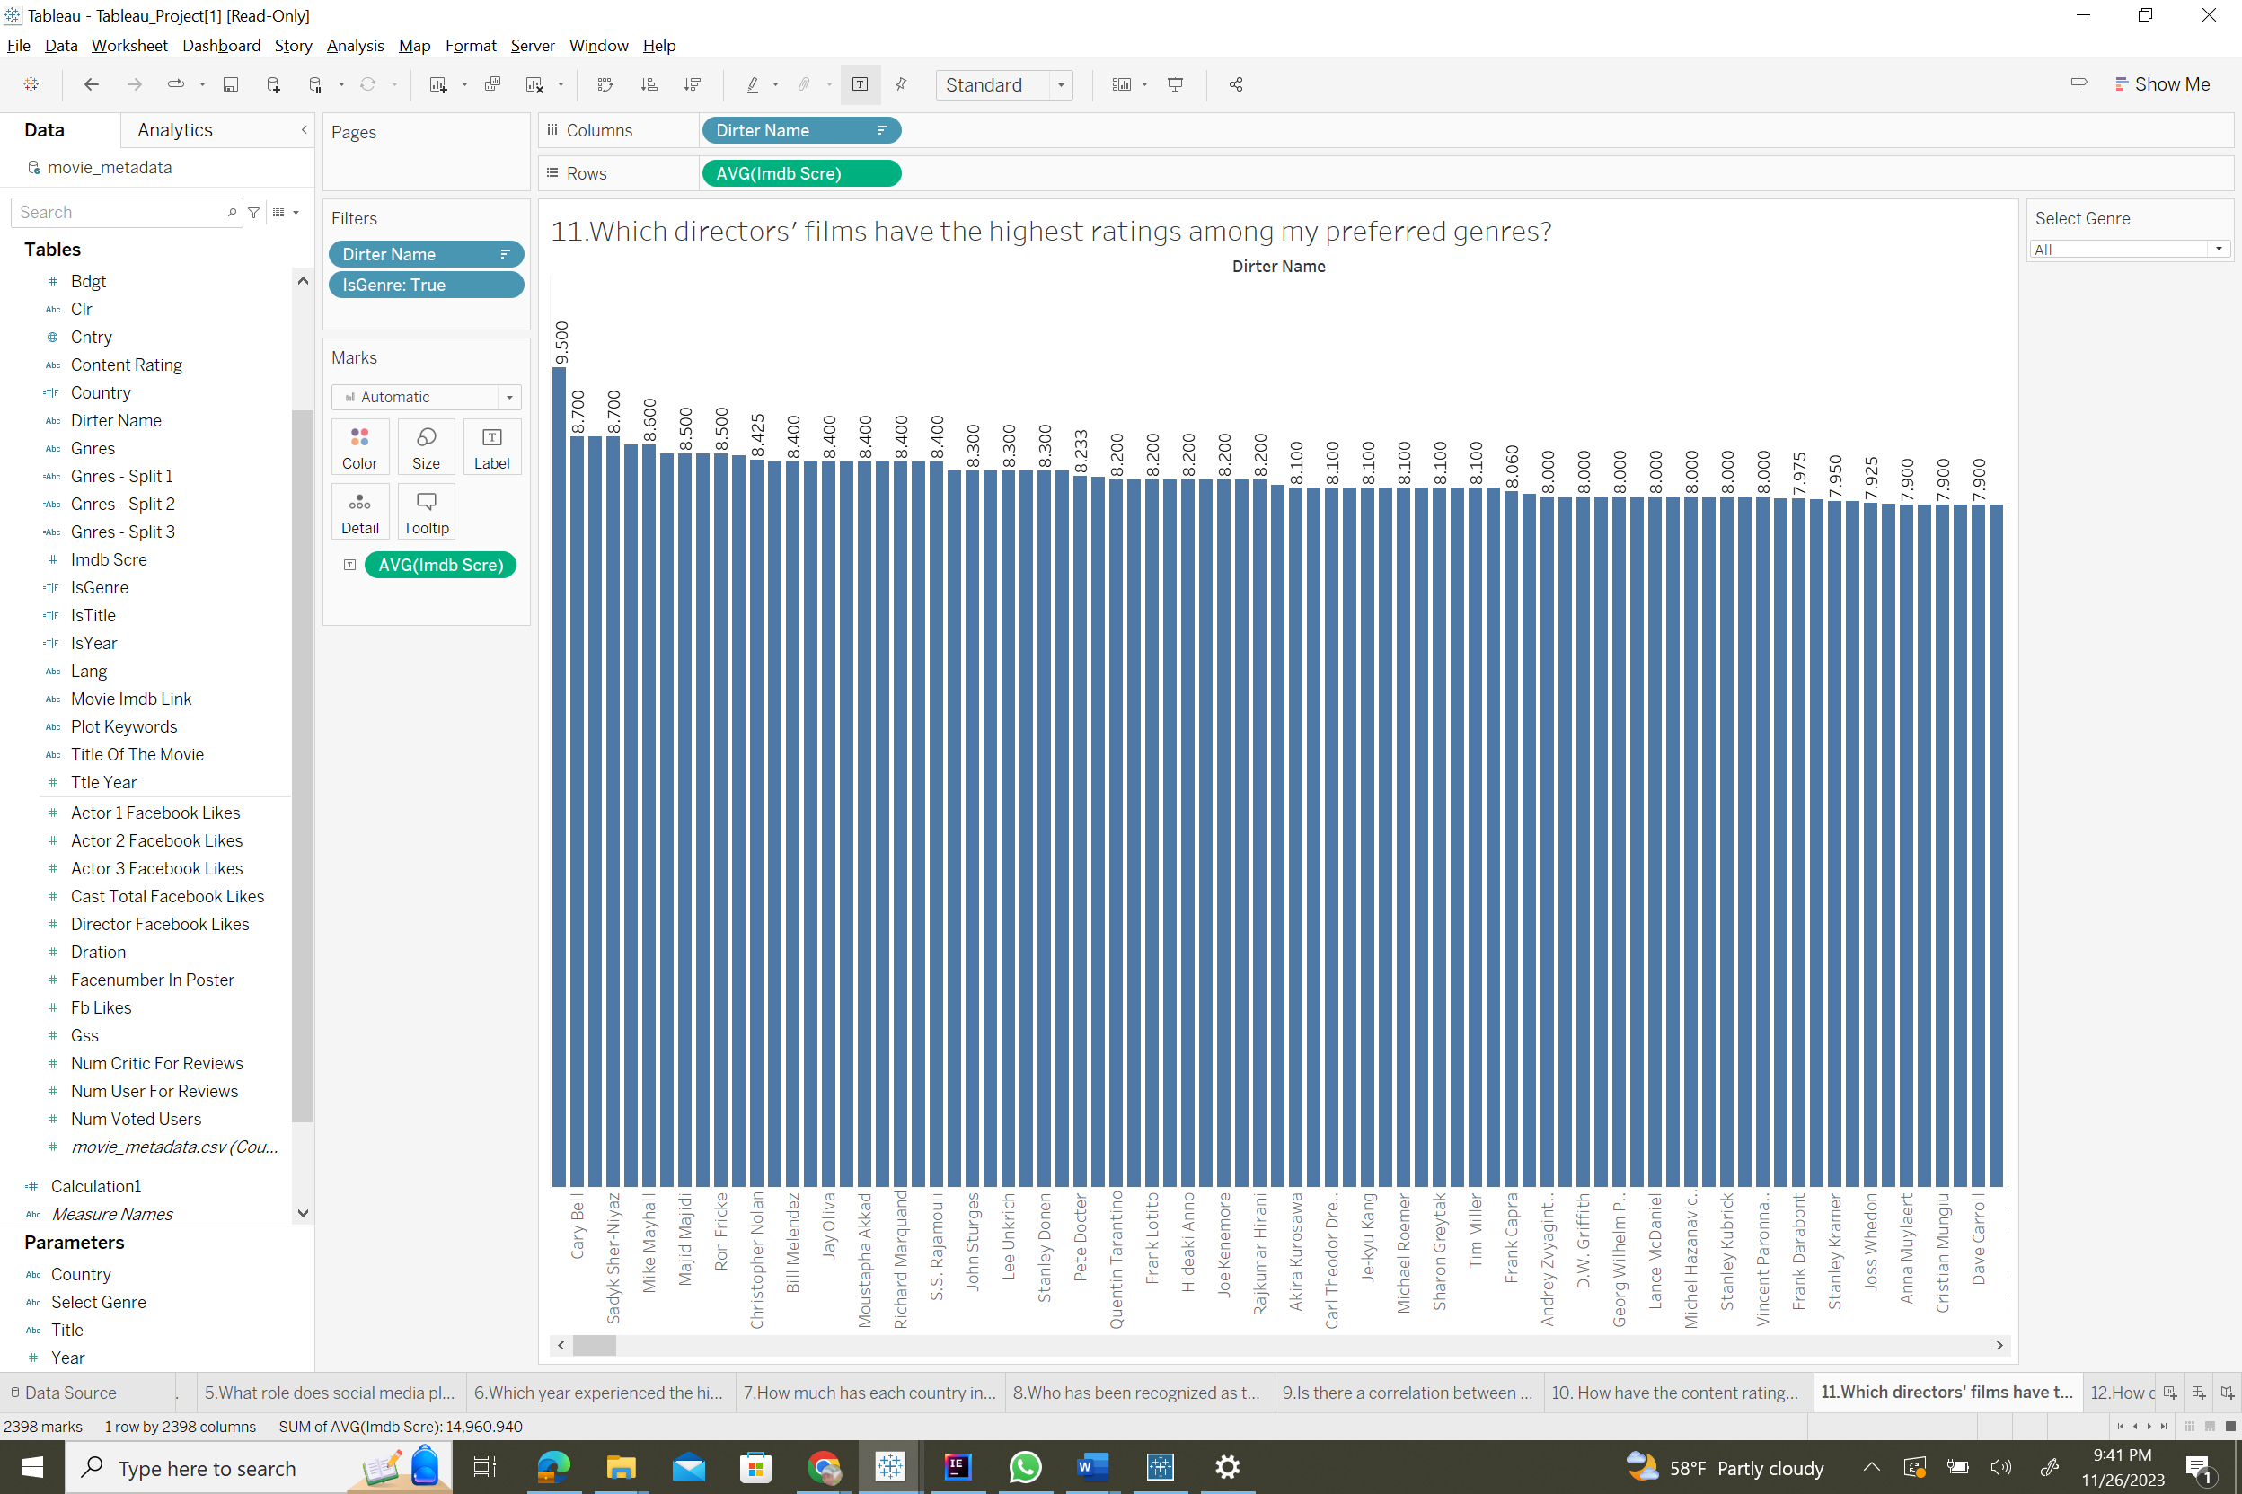

1. How does the cast size relate to the budget required for a movie's production?

The visual is a bar chart that depicts the budgets of numerous movies, split by cast configuration. The X-axis indicates that each bar represents a unique mix of performers, while the Y-axis indicates the expenditure associated with each movie's production. The chart compares how cast size, and the participation of specific actors may relate to the financial investment in a film's production, providing insights into film budget costing tactics with regard to casting decisions.

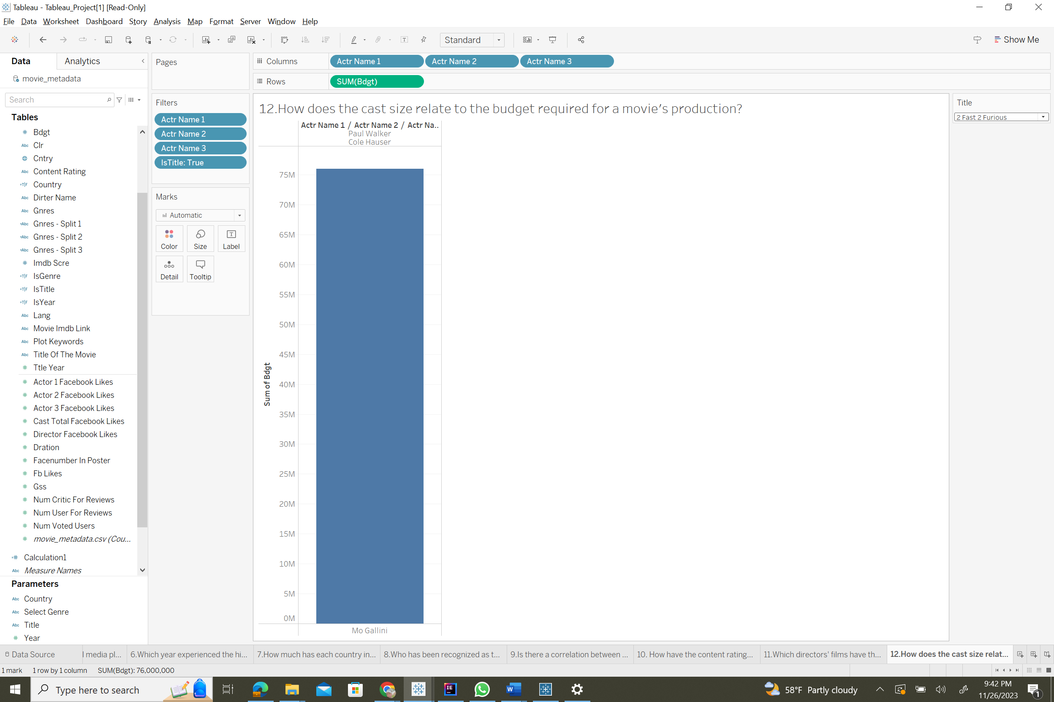

## **Section 6 - Dashboard Interactivity**

We've employed various interactive features such as calculated parameters, reference lines, filters, and calculated fields to cater to different scenarios. One of the key features is the calculated parameter, which allows users to select specific genre attributes for data filtering, resulting in clearer and more refined data visualizations.

We've included an 'all' option within the genre parameter to enable the exploration of various genres and access to movie-related information. To make this feature function effectively, we've created a calculated field that filters data exclusively for the selected genre. This parameter is also utilized in visualizations tied to genre selection (specifically, Questions 9 and 11).

In addition, we've incorporated internal filters for both the 'Genre' and 'Budget' parameters in our visualizations to display the relationships between IMDb scores and budget, with the budget being represented as a range of values.

The genre parameter's value range is dynamically loaded from the 'Genres' attribute within the dataset, ensuring that all available genres are accessible for selection.

## **Extra Credit**

**Tableau Prep Builder Part**

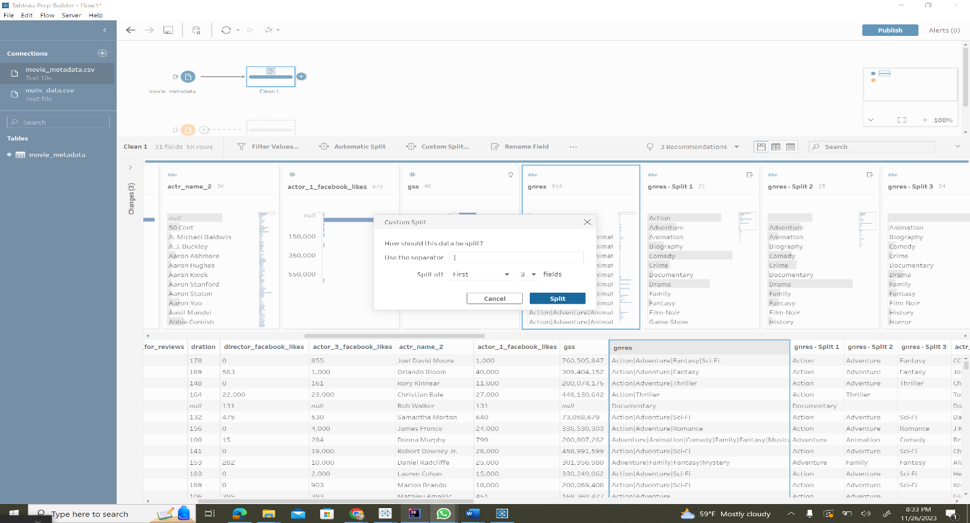

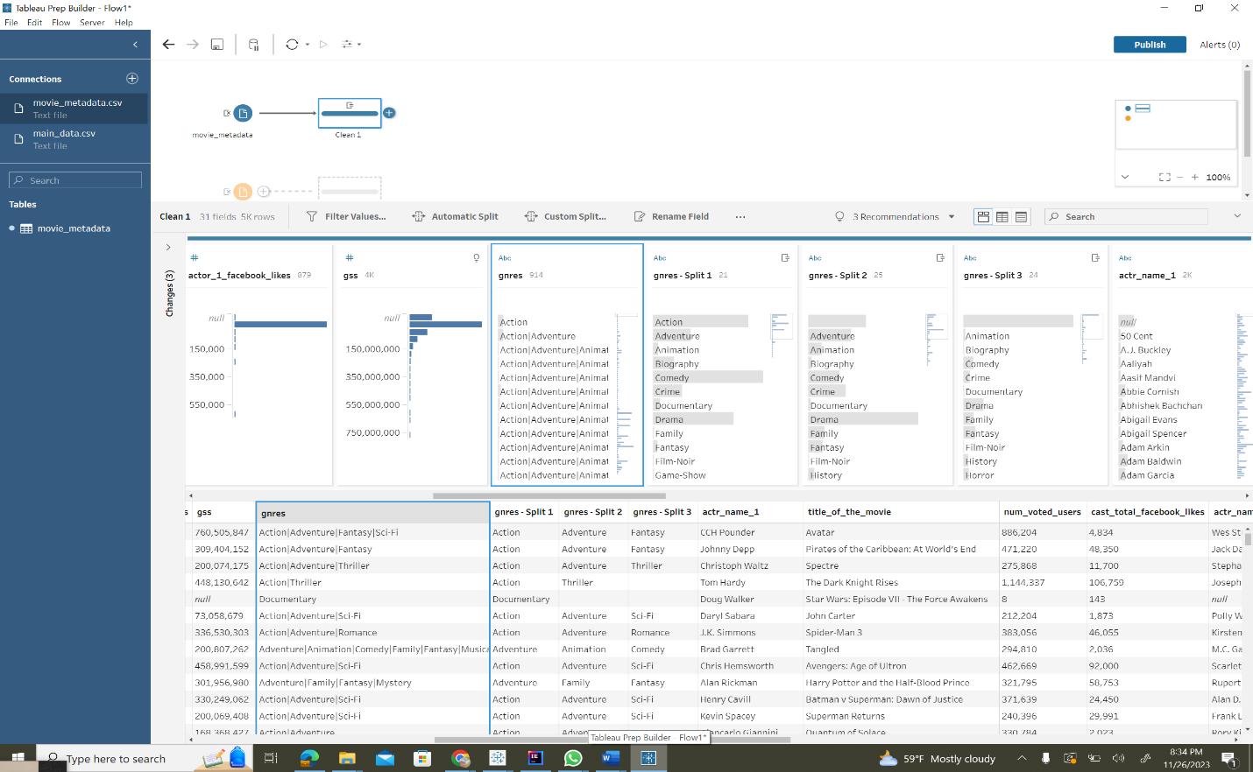

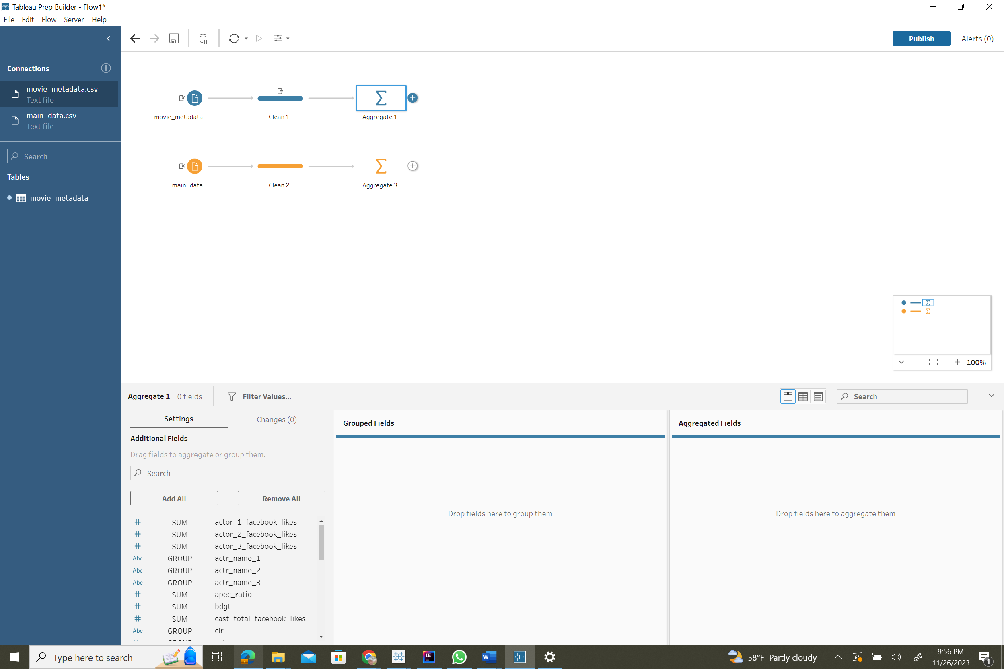

**Using Maps**

In the image below, color is used to depict the total budget allocated by each country for their respective movies. The intensity of the color indicates the magnitude of the budget, with darker shades representing higher expenditures. Key pre-attentive attributes employed in this graph include color and position.

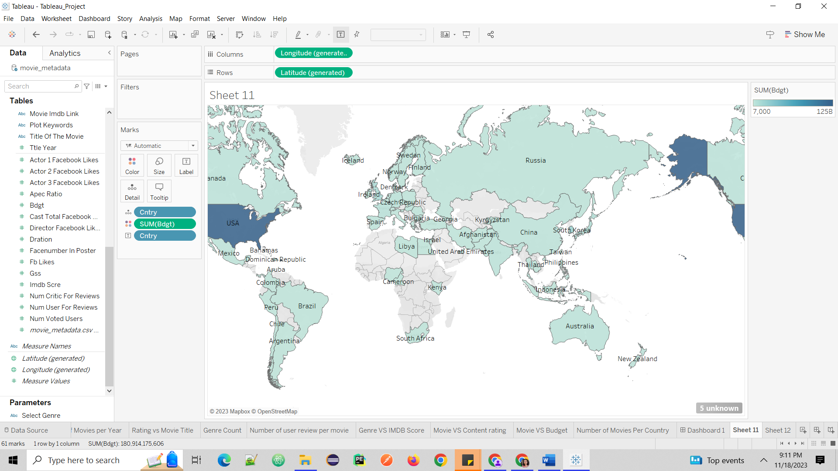

# **References**

## **Mural Board**

* <https://app.mural.co/t/dvproject4830/m/dvproject4830/1699563634432/41164a00ee4d15bf041988db73e8d938b1dbbfb0?sender=u532456dadd8ca56710e31855>

## **Data Set**

* <https://www.kaggle.com/datasets/bobirino/movie-metadata/data>

## **Published Tableau**

* [Tableau_Project_Team2 | Tableau Public](https://public.tableau.com/app/profile/pavan.kalyan.imadabathini/viz/Tableau_Project_Team2/FinalDashboard?publish=yes)